

FINANCIAL MARKETS & INSTRUMENTS (FMI)

INDIVIDUAL STOCK CHALLENGE

Tutorial Group
TF01

Name / Student ID

Cheng Zung Kai

Trading Notes and Decisions
Portfolio Performance
Participating in this stock picking challenge was overall quite an insightful experience even though I was unable to meet the goals that I had set for myself. Overall, I had a return of -7.7% which was much lower than the total return of STI of 4.4%. This was quite disappointing, especially after all the time and effort I had put into monitoring the markets and making trades. However, it was definitely beneficial for me to learn more about my preferences when trading, such as my risk appetite.
The challenge also made me more aware of how my emotions can influence my trading. At certain times I chased short term gains despite the high risks involved with them leading to losses which could have been avoided if I had conducted proper market research beforehand. Going forward I intend to be much more intentional and disciplined with my strategy. Conducting proper fundamental and technical analysis before purchasing a stock.
Another of the biggest lessons I learnt during the Stock picking challenge was the importance of risk management. After looking back on this challenge, I realised that many of losses came from taking on too much risk in hopes for larger returns. There were many occasions that when I held onto my losing positions in the hopes that they would turn positive, however, this would often times result in an even larger loss to my portfolio. A large majority of my holdings were tied to the US markets and as such I was exposed to a high amount of market volatility.
Financial Instruments
Large Cap Stocks
Large Cap stocks made up a large portion of my holdings, it was the instrument that I traded the second most throughout the stock picking challenge.
Trade 1 – 28 April UOB Buy
I bought 300 UOB shares at $34.37 on the ex-dividend date, aiming to take advantage of the usual short-term dip that follows a dividend payout. My goal with this trade was to capture a profit as the price stabilised after the dip. My Strategy was based on the idea that UOB has strong fundamentals and investor confidence and as such the stock price would usually rebound after the temporary dip caused by dividend-chasing investors selling their stock.
Trade 2 – 20 May UOB Sell
After holding the stock for about three weeks, UOB's share price rose to $35.58, showing a recovery of $1.21 per share from my entry position. At this point, I chose to exit the position to lock in profits, since my price target was reached and I believed that the upside potential beyond that point was limited. Additionally, the market was still quite volatile at this point due to emerging trade decisions by the US and as such I wanted to reduce my exposure to this volatility.
Trade 3 – 30 April Keppel DC Reit Buy
I decided to invest in 1000 shares of Keppel DC Reit in order to gain exposure into the growing data centre real estate sector as these data centres are a key enabler of many different tech-driven industries such as AI. Keppel DC Reit is one of the most established data centre Reits in Asia, it holds 8 assets in Singapore, giving it the largest market share in one of the world’s most competitive data centre markets. Beyond the fundamentals, as REIT, Keppel DC pays out regular dividends of 4.03%, making it a more attractive investment.
Trade 4 – 13 May DBS Buy
I purchased 300 shares of DBS at $44.20 on 13 May due to a strong earnings report and favourable market conditions. That week, DBS had released their Q1 2025 earnings, which despite seeing a year-on-year dip still beat expectations. The timing also coincided with a larger market rebound triggered by the easing of trade restrictions between China and the US. I viewed this as a good entry point into one of the most consistently well-performing large-Cap stocks in Singapore.
Trade 5 -15 May DBS sell
Just two days later, on 15 May, the share price rose to $44.93, and I chose to close my position. This gave me a short-term gain of $0.73 per share, or around $200 after fees. Given the quick rebound and broader market uncertainty, I felt it was a good time to take profit rather than risk a reversal. Furthermore, DBS had their ex-dividend date on the 16 of May, thus the stock might have dipped due to the short-term dividend seeking investors exiting their positions. Overall, I think that my exit on this trade was well timed as DBS stock did indeed dip to $44.40 on May 16.
Trade 6 & 7 – 13 May SGX Buy
I initially purchased 1000 shares of SGX stock at $14.17 and an additional 700 shares at $14.10, totalling 1700 shares at an average price of $14.14. This trade was made purely based on one technical signal. The RSI of SGX dipped to below 30 indicating that the stock might be oversold. In hindsight, this was not a proper approach to trading. Relying on one indicator without any supporting confirmation from other technical or fundamental analysis caused my investment to be much more uncertain.
Trade 8 & 9 – 29 May 30 June SGX Sell
After entering into this position, the price of SGX stock dropped to around $13.60 for a 2-week period making it difficult for me to exit as I did not want to lock in my loses. Thus, when the price of SGX recovered to $14.26 on 29 May, I sold 800 of my shares as I was unsure if the price was going to continue to rise. On the week of 27 June, SGX price rose rapidly to its 52-week high, and as such I sold the rest of my SGX stock at 14.80. This trade was one of my more Insightful trades that I had made as it showed me that just simply basing my trades off of 1 indicator was not a good way to go about trading. However, it also showed me that even if my entry is weak, if I hold that shares of a company that has strong fundamentals and be patient, the price is likely to eventually rebound and go into a profit.
Throughout the stock picking challenge, large-cap stocks formed a core part of my portfolio and were the most profitable out of the 4 instruments that I traded. Large-Cap stocks are the least risky out of the 4 instruments which is why I also personally trade them outside of the stock picking challenge. One key reason large-cap stocks performed well was due to their inherent lower risk. Many of these companies, such as UOB, DBS, and SGX, are blue-chip stocks with established business models, strong balance sheets, and consistent earnings. This gave me greater confidence in holding them, even during short-term market dips. I learned that patience and discipline are crucial when trading large caps while they may not move as quickly as smaller stocks, their long-term growth tends to be more sustainable, and profits often come to those who are willing to wait through short-term volatility. With proper fundamental analysis and patience, holding some of these large-cap stocks for long periods would more often than not result in a profit. While technical analysis was not as important for Large-Cap stock, it is still important to allow for a more preferable entry position. Another factor that I learnt that I had to take into account when trading was the effects of macroeconomics on stock prices. The easing and tightening of trade restrictions as well as other global events would often have a large impact on these stocks. Thus, going forward in my own investing journey I will always keep in mind current economic conditions around the world when investing into a given stock.
Daily Leverage Certificates
Daily Leverage Certificates (DLCs) also made up a large portion of my portfolio as since we were trading instruments within the Singaporean markets, DLCs were the only way I was able to get exposure to the US markets. However, since the DLCs of US stocks price primarily moved based on news that is released in in day for US, thus there were many situations where I incurred more losses due to being unable to close my position over night. This combined with the inherent risk of trading DLCs caused them to be the source of the majority of my losses.
Trade 10 - 2 May Nasdaq 5xShort G251216 Buy
On 2 May I purchased 20000 units of Nasdaq 5xShort at $0.174 per share. The main reason why I bought this DLC was due to the rising trade tensions between China between China and the US. China is a large supplier of many of the AI chips and other technology used by many of the tech firms in the Nasdaq, the weakened relations between the 2 countries would likely result in a large increase in costs for many of the firms in the Nasdaq, which would in turn reduce investor confidence and cause the entire index to decrease. Thus I believed that this was a good entry for my short DLC.
Trade 11 – 8 May Nasdaq 5xShort G251216 Sell
On 8 May, US announced that they were easing the trade restrictions placed on the sale of AI chips. This development improved market sentiment drastically, pushing the Nasdaq higher. Furthermore, US signed a trade deal with the UK as well causing investor sentiment to improve even more, thus knowing that I would incur more losses If I were to continue holding my position, I decided to cut my losses and sell my short at $0.166 per share. Even though my thesis for this trade made sense, unexpected macroeconomic factors caused me to lose money on this trade.
Trade 12 -5 May NVDA 3xShortSG261006 Buy
I purchased 4000 units of a 3xNVDA short for similar reason to my purchase of the Nasdaq short. The ongoing trade war between China and the US would greatly affect NVDA’s sales and would increase their costs drastically since they source many of their parts directly from China. Furthermore, on the previous US trading session, NVDA stock hit a strong resistance that it had rebounded from multiple times before. This was a strong indication that the stock would likely dip afterwards. Thus, I decided to enter into my position then.
Trade 13 – 8 May NVDA 3xShortSG261006 Sell
As mentioned earlier, On 8 May, the U.S. announced it would ease restrictions on AI chip exports. This shift significantly boosted market sentiment, especially within for NVDA as the stock jumped 3% within a night. This caused my DLC position to drop even further and on 8 May I decided to cut my losses and close my position at $1.30 per unit so that I would not incur any more future losses.
Trade 14 – 13 June Nasdaq 5xShortSG251216
On 13 June, I purchased a short DLC on the Nasdaq, aiming to profit from potential downside risk in U.S. tech stocks. This decision was driven primarily by growing geopolitical tensions, specifically the outbreak of conflict between Iran and Israel, which raised concerns about global market instability. At the time, markets were showing signs of nervousness, with increased volatility. The Nasdaq, which had been trading near recent highs, appeared vulnerable to a pullback given its concentration in risk-sensitive tech stocks and the broader uncertainty surrounding how the conflict could affect oil prices, and investor sentiment. Thus, I purchased a Nasdaq short in the hopes that I would be able to profit from it. This trade reflected a macroeconomic driven approach, where geopolitical risk was the main catalyst.
Trade 15 –13 June S&P 7xShortSG260324
On 13 June, alongside my Nasdaq short, I also bought a short DLC on the S&P 500 in response to rising geopolitical risk from the Iran-Israel conflict. I expected global uncertainty to weigh on U.S. markets, particularly broad indices like the S&P 500
Trade 16 &17 – 25 June Nasdaq 5xShortSG251216 & S&P 7xShortSG260324 sell
On 25 June, I sold both my Nasdaq and S&P 500 short DLCs at a significant loss following the announcement of a ceasefire between Israel and Iran. This sudden shift in geopolitical tensions triggered a rebound in global markets, especially in U.S. indices, which moved sharply higher. With the core reason for my short positions no longer valid, I made the decision to exit and limit further losses. This sell highlighted the risk of holding leveraged instruments during unpredictable macro events, and reinforced the importance of having a clear exit plan when the trade thesis breaks down.
Overall I learnt that trading DLCs was not for me personally as the risk involved was much too large for me.
Penny Stocks
Throughout the stock picking challenge I only traded 1 penny stock which was Rex Intl, I chose this penny stock because the stock had recently seen increased trading volume, and oil prices were trending higher due to rising Middle East tensions and summer demand expectations. I saw this trade having potential for short-term gains if energy markets remained strong.
Penny stocks are not an investment that I really considered throughout the stock picking challenge and in my own investment journey mainly due to the risks involved with investing with an unproven company.
Warrants
Similarly, I also only traded 1 warrant during the duration of the stock picking challenge, that being OCBC Bk MB eCW250930. I bought this warrant because I saw the potential for a rise in OCBC shares and wanted a leveraged position to make more profits out of the rise. The warrant's expiry in September 2025 gave me enough time to position for a potential upside move, especially if market sentiment remained positive or if OCBC delivered solid performance in the next earnings cycle.
I did not trade warrants during this stock picking challenge as it made more sense trading DLCs if I wanted a leveraged position. Trading DLCs gave the same advantages as warrants without having to worry about the decay and expiry of the warrant. Although in practice there are definitely reasons to choose warrants over DLCs
2 CIQ Pro Features
The first feature of CIQ Pro that helped me during this stock picking challenge was the comparison feature was the comparison feature, it to assess the valuation and performance of companies within the same sector. It let me compare key metrics like P/E ratio, ROE, dividend yield, and EPS growth across SGX-listed firms, which helped me make more informed stock picks. For example, I used it to compare the EPS of the top 3 banks in Singapore, DBS UOB and OCBC in order to decide the company that I should invest in.
The other feature that I used was the securities screener feature. This feature allowed be to screen through many different stocks based on certain filters like Equity type Industry classification and exchange. This screener was valuable in helping me to find new stocks that I could potentially invest in, saving me a large amount of time.
Investing Note Feature
The investing note feature that I thought was quite helpful was the portfolio comparison feature. This feature shows the returns your portfolio has provided in comparison to indexes like the STI. I think that this feature was quite useful to be throughout the challenge as It gave me good insight into how well my portfolio was doing. It also showed me that I could have ventured into purchasing ETFs tracking certain indexes.
Key Takeaways
One of the most important lessons I took away from this stock-picking challenge is that it’s not just about spotting good opportunities it’s also about proper risk management after committing to the trade. Going into this, I spent a lot of time researching trends, analysing stocks, and even following macroeconomic developments. But I quickly realised that none of that matters if I don’t execute the trade with discipline. There were trades where I was convinced I was right like the Nasdaq and NVDA shorts so I held onto my position even after the original trade idea fell apart. I didn’t set clear stop-losses or define exactly when I would exit the position. Instead, I hoped the market would turn in my favour, and that hesitation cost me. I also found myself making more emotional trades when I was heavily in the red. When my portfolio was down about 3-4% I was very determined to get back into profits and as such I took much more risk when making my trades and abandoned a lot of my fundamental and technical analysis. Although I was hoping to profit from these trades they usually ended up causing me to lose more money. Thus during my own trading experience in the future I would definitely be more inclined to add a stop loss for all my trades and if I make a few losing trades I would take a short break from trading and make sure that my emotions do not take over my trading.
Another key takeaway for me was the impact of macroeconomic events on the prices of stocks. This challenge made me realise how quickly the market can react to global events and how unpredictable those reactions can be. I entered trades based on logical macroeconomic reasoning, especially when shorting the US market due to geopolitical tensions. For example, during the Iran-Israel conflict, I expected that fear and uncertainty would pull down US markets, particularly tech-heavy indices like the Nasdaq. And initially, it seemed like that would happen. But just days later, a sudden ceasefire was announced, and all my short positions went into the red practically overnight. This taught me that even if my trading idea is good it is nearly impossible to predict the news and other global events that will occur. Going forward, I will be more cautious about relying too heavily on trades during times of economic uncertainty and market volatility, especially with leveraged instruments. Although these events have the possibility of allowing me to profit greatly, the losses that can be incurred from them are just as great.
The last key takeaway I had from this stock picking challenge was learning about my own risk tolerance. Before this stock picking challenge, I had a general sense that I leaned toward safer investments as personally I mainly invested in ETFs tracking the US market, but going through the ups and downs of this challenge made that preference very clear. Experiencing real-time price swings, especially with volatile instruments like DLCs and leveraged positions, helped me understand what kinds of risks I’m actually comfortable taking.
At the start of the challenge, I thought I could handle high-risk, high-reward trades, especially with DLCs that gave exposure to the US market. But I soon realised that the stress and uncertainty of holding these positions made it difficult for me to trade with a clear head. When markets moved against me quickly, I didn’t always have a plan, and the emotional toll affected my decision-making. In contrast, when I was holding large-cap stocks like UOB, DBS, and SGX, I felt more in control. These companies had strong fundamentals and lower volatility, which gave me the confidence to stay patient and make rational decisions.

Appendix
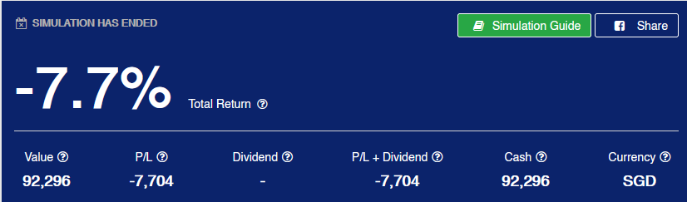
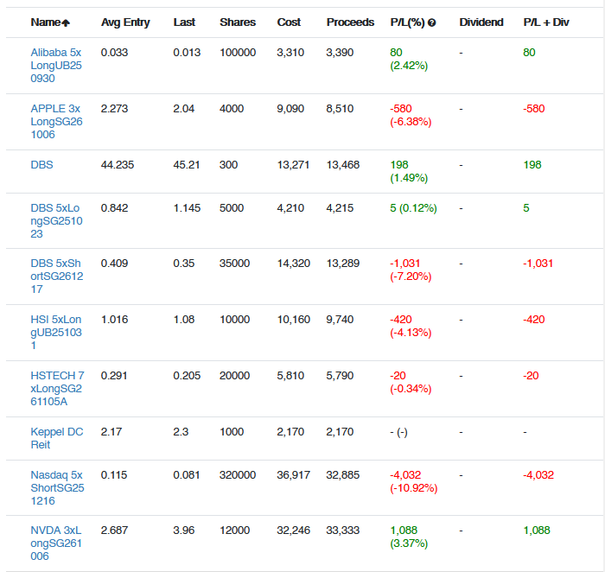
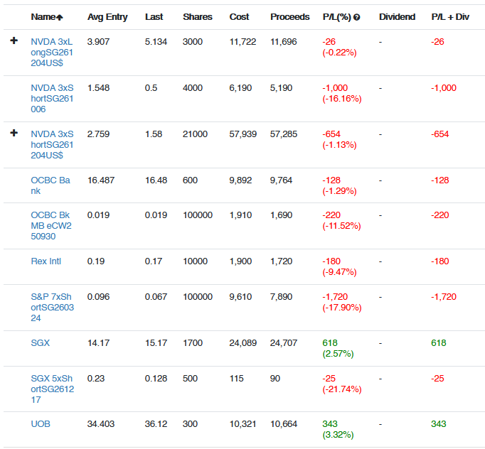
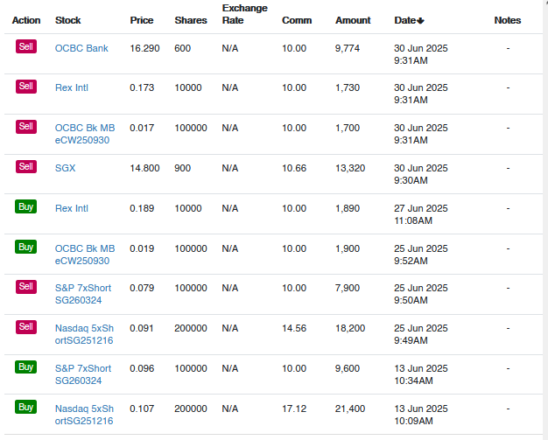

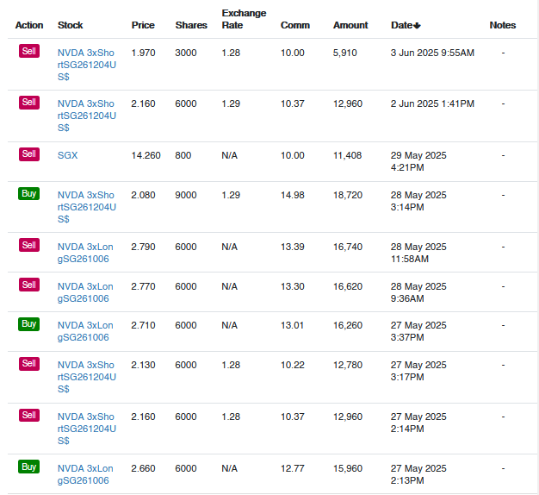
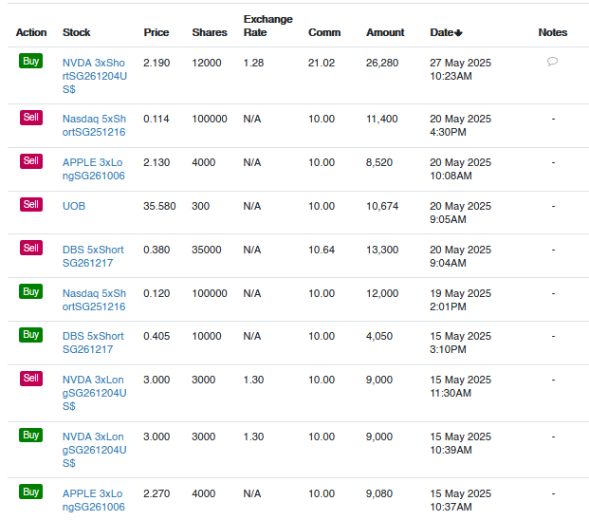
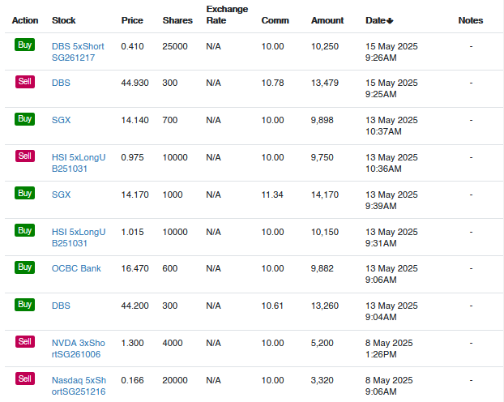
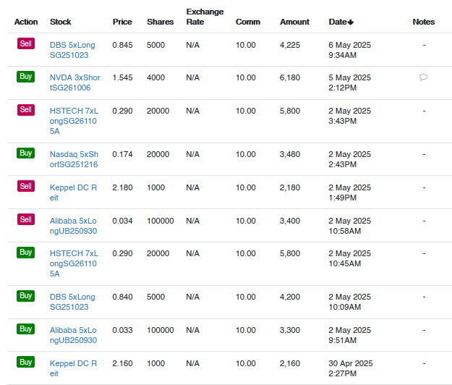
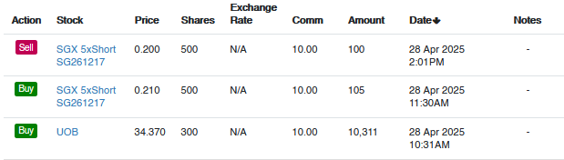
Disclosure Statement for Use of Generative AI

Name of student(s):
Module & Tutorial Group:

(W.e.f April 2025 semester)
For students who did not use any generative AI tools

I/ we declare that the submitted work was produced without using any generative AI tool for idea generation or improvement of original writing. I/we am/are aware that any failure to declare the use of generative AI will be considered as an act of academic dishonesty and students found guilty will be dealt with in accordance to the NP Plagiarism Policy.

Name of student(s): Cheng Zung Kai
Module & Tutorial Group: FMI TF01
For students who have used generative AI tools

Specify the generative AI tools used and the respective purposes.
 |  | Generate materials for background research  Note: Materials produced by generative AI tools need to be referenced to avoid plagiarism  [Put an “X” in the appropriate box(es)  below] | Improve the academic tone and accuracy of language, including grammatical structures, punctuation and vocabulary  [Put an “X” in the appropriate box(es) below] | Others  [Specify use below]
ChatGPT |  | x | x
Grammarly
GrammarlyGO
Marmof
QuillBot
[Specify name of Gen AI
Part 2
List the prompts used in the generative AI tools
Generative AI Tool | Prompt/ Link* for Chat Content
Chatgpt | What are some financial events that happened on may 8
Chatgpt | Improve the grammer and tone of my reflection

* Refer to https://www.youtube.com/watch?v=JIWeUTHvypg to create shareable link for various AI tools.

Part 3
[Put an “X” in the box below]
x
I/ We acknowledge that I/ we have checked and verified the output of the generative AI tools.

I/ We acknowledge that I/ we have adapted and modified the output of the generative AI tools for this assessment.

I/ We acknowledge that I/we have provided the necessary in-text citations and references to the generative AI tools used in our assessment.

I/ We acknowledge that the following records will be kept and may be requested from me/ us.
- Drafts of work before/ during use of the generative AI tools
- History of use of generative AI tools for this assessment

Disclosure Statement adapted from https://www.monash.edu/student-academic-success/build-digital-capabilities/create-online/acknowledging-the-use-of-generative-artificial- intelligence and https://vascular.org/vascular-specialists/research/journals/declaration-generative-ai-scientific-writing.

